**International Police Association-Section Montenegro**

**Union of the Police Directorate of Montenegro**

**Association of Women Police Officers of Montenegro**

**WORLD CONFERENCE OF WOMEN IN THE SECURITY SECTOR**



**“How to promote a job in the security sector and involve more women to do it and how to professionally encourage women in the security sector for career advancement”**

**19th-22nd February 2019, Budva, Montenegro**

**Work program**

* Arrival of guests is planned for 19th February 2019.
* The formal opening of the Conference will take place on 20th February.

At the ceremonial opening, it is necessary to come in the police uniform i.e. the Armed Forces uniform of the country you represent and bring a flag of the country you represent which you will be using only at the ceremonial opening.

* Contributions will be presented on 20th and 21st February. The schedule of the presentations will be subsequently determined for each delegation, depending on the number of delegated delegations, and you will be informed on it in a timely manner.
* Closing the conference and declaring the best presentations will be held on 21st February at the final gala dinner.
* A free trip to Sveti Stefan, Kotor , Perast and Tivat will be organized for guests. The time for the trip will be determined later, when we have in have information about the number of participants in the event, about which you will be notified in a timely manner. Apart from them free trips provided by the Conference organizer, we can organize trips as desired in you free time.
* Departure of guests is planned for 22nd February 2019.

Guests who, due to organizing a trip or because of their desire to stay longer in our country, come earlier or stay longer than it was indicated, can stay in the hotel where the Conference will be held at a more favourable price than the regular one.

**Each delegation is required submit a presentation of the measures implemented by their respective organization in order to achieve gender equality, in English lasting from 10 to 15 minutes. Presentations should be submitted by 15th December 2018, on the mail address:** [**world.conference2019@gmail.com**](mailto:world.conference2019@gmail.com) **of the delegation will present it at the Conference is obliged to bring it to the Conference in electronic from.** Three presentations, on the basis of which our Section will be able to define concrete measures for increasing the number of women in the Montenegrin security sector, will be rewarded at the final gala dinner**.**

Invitation for the Conference is addressed to both men and women, because this topic is not only for women, but on the contrary, men play an important role in the process of decision making and achieving gender equality, so it is desirable that the delegation includes women and men.

Number of participants is not limited.

**Deadline for registration is 15th December 2018.**

The working languages are English and Montenegrin.



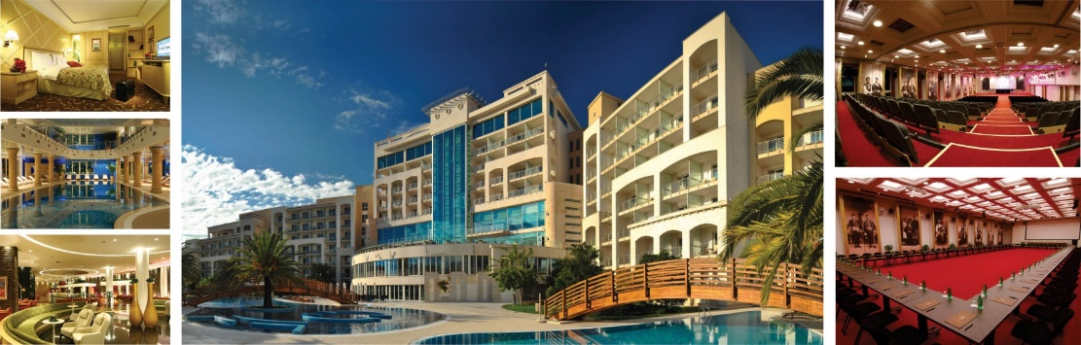

The price of a three- day package in a double room is 249,00 Euro per person.

The price of a three- day package in a single room is 335,00 Euro per person.

Package price incledes:

* Three overnight stay in a superior room,with breakfast and dinner,
* Wellness centre services,
* Wi-fi internet in all rooms and on the entire surface of the hotel,
* Residence tax,
* Transport-airports of Tivat and Podgorica.

More information about the hotel can be found at: **www.montenegrostars.com**

Should you need anything that is not included in the package price, please contact us at the e-mail address: [**world.conference2019@gmail.com**](mailto:world.conference2019@gmail.com)

Should you need transportation that is not included in the package price(airport of Ćilipi, Dubrovnik, Croatia, bus stations, railway stations, ferries Bar-Bari, local transport, organizations of individual excursions or other modes of transport), please contact the proven carrier that will be at your service at affordable price: [**www.viptaxi.me**](http://www.viptaxi.me)[**viptaxi@t-com.me**](mailto:viptaxi@t-com.me)

**Payment instructions:**

**The deadline for payment of the full amount is 15th December 2018 .**

Payment is done in euros, electronically by signing up and booking at [**events@montenegrostars.com**](https://mail.gov.me/owa/redir.aspx?SURL=kBMxIhf9A-mvKtCRs7DeltU1g7nT4xfny42wtjzBSnIUxzpBLO_VCG0AYQBpAGwAdABvADoAZQB2AGUAbgB0AHMAQABtAG8AbgB0AGUAbgBlAGcAcgBvAHMAdABhAHIAcwAuAGMAbwBtAA..&URL=mailto%3aevents%40montenegrostars.com). After booking from this address, you will receive instructions for foreign currency payment. For more information and payment instructions visit [**events@montenegrostars.com**](https://mail.gov.me/owa/redir.aspx?SURL=kBMxIhf9A-mvKtCRs7DeltU1g7nT4xfny42wtjzBSnIUxzpBLO_VCG0AYQBpAGwAdABvADoAZQB2AGUAbgB0AHMAQABtAG8AbgB0AGUAbgBlAGcAcgBvAHMAdABhAHIAcwAuAGMAbwBtAA..&URL=mailto%3aevents%40montenegrostars.com).

**Montenegro wild beauty…** <https://www.montenegro.travel/en/>

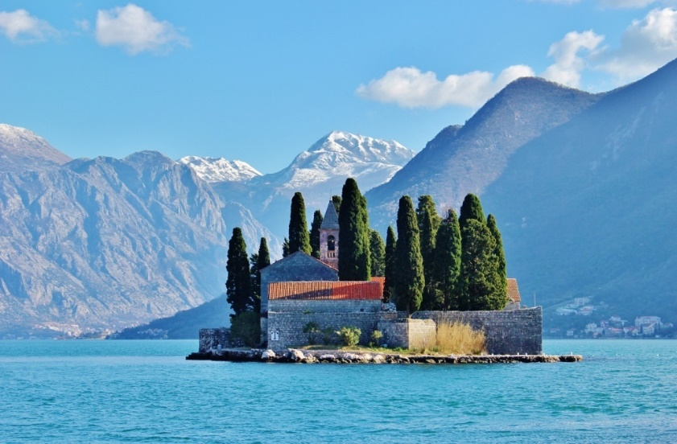The picturesque country of Montenegro is a country situated in the southeastern part of Europe. The country of Montenegro, apart for its scenic mountains, is also known for its out-of-the-world beaches that owe their existence to the proximity that the country enjoys with the Adriatic Sea.

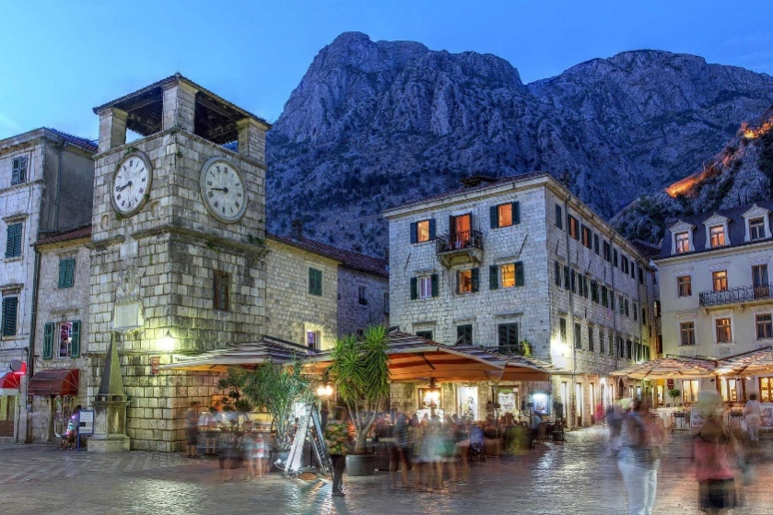Bordered by the clear sea, covered with white rocks, sunlit by the Mediterranean sun, Montenegro is one of the last European oases to which one can flow from the dynamic tempo of civilization and rest by the soft sound of the waves, the song of crickets and the intoxicating scents of miscellaneous vegetation. When you reach Montenegro, through whichever ”door” you enter, you will encounter intact nature and be welcomed by hospitable, proud and friendly people.

The Capital is Podgorica and Budva is the most visisted city in Montenegro. As unique scenery, in Montenegro you have to visit the 1300 meter deep canyon of the River Tara, the deepest one in Europe, second in the world after the Grand Canyon of the Colorado River in America. If you wish to stop and rest – to fill your lungs with clean air, and your eyes with the beautiful landscape, many belvederes or meadows located on plateaux, places of peace and serenity, are waiting for you… In Montenegro, you will be greeted by people, who have learned, through tradition, to respect a well-intentioned guest. You shall be welcomed by people loyal to the country they live in, loyal to the moral, customs and history.

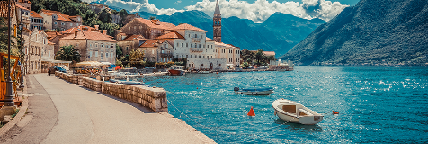

**Transportation**

You can get in Montenegro by plane, train, car, bus or by boat. There are 2 international airports in Montenegro, Podgorica and Tivat. Podgorica airport is located 60 km from Budva and has daily scheudled flights to varius world destinations. Tivat airport is the ideal choice for arrival on Montenegrin coast. It is only 20 km away from Budva.

Another possibility is to use Airport in Dubrovnik in Croatia which is 16 km away from Montenegrin border(please note that we will organize transport only from airports and bus stations in Montenegro). There several low cost comapnies so you can get to Montenegro cheap from almost all European cities.

Montenegro has railway line conecting Bar to Belgrade which connects it with the European reilway net.

Montenegro is easily accessibile by road from Croatia, Serbia, Albania and BiH.

Montenegro is conected to the rest of Eaurope by ferry through Italy.



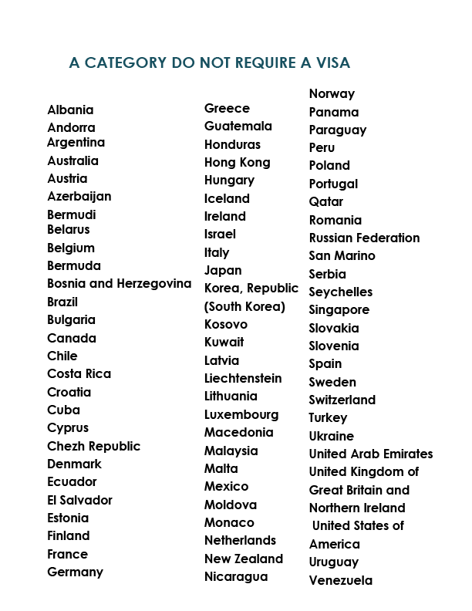

**B category REQUIRES A VISA**

**AFGHANISTAN**

Embassy of the Republic of Serbia in Sofia.

Tel.: (+359-2) 9627476

Email: afgembassy_in_sofia@yahoo.com

**ALGERIA**

Embassy of the Republic of Serbia in Algeria.

Tel. +21321 / 69-12-18, 69-27-04, 69-23-26

E-mail: ambasada@ambserbie-alger.com

Web: www.ambserbie-alger.com

**ANGOLA**

Embassy of the Republic of Serbia in Luanda.

Tel. +2442 / 32-14-21, 32-03-93

E-mail: yugoemb@usa.net

yugoemb@snet.co.ao

**ARMENIA**

Embassy of the Republic of Bulgaria in Armenia

or Montenegrin Embassy in Moscow.

Tel.: +7 495 230-18-65

E-mail: ambasada@ya.ru

**BAHAMAS**

Consulate General of Montenegro in New York.

Tel. +1 212/-66-15-40

E-mail: office@montenegroconsulatenewyork.info

**BAHRAIN**

Embassy of the Republic of Serbia in Kuwait.

Tel.: +965 / 532 75-48, 532 75-49, 532 54-02

E-mail: embrskw@qualitynet.net

embrskw@yahoo.com

**BANGLADESH**

Embassy of the Republic of Serbia in New Delhi.

Tel.:+9111/2687-36-61, 2687-20-73

Consular affairs: consul@embassyofserbiadelhi.net.in

Web: www.embassyofserbiadelhi.net.in

**BARBADOS**

Consulate General of Montenegro in New York.

Tel.: +1 212/ 66-15-40

Email: office@montenegroconsulatenewyork.info

**BELIZE**

Diplomatic or consular posts of Montenegro or nearest diplomatic or consular posts of Serbia.

**BENIN**

The nearest Embassy of the Republic of Serbia.

**BHUTAN**

Embassy of the Republic of Serbia in New Delhi.

Tel.: +9111 / 2687-36-61, 2687-20-73

Consular affairs: [consul@embassyofserbiadelhi.net.in](mailto:consul@embassyofserbiadelhi.net.in)

Web: www.embassyofserbiadelhi.net.in

**BOTSWANA**

Embassy of the Republic of Serbia in Pretoria.

Tel.: +2712 / 460-5626, 460-61-03, 346-41-39, 346-61-91

Web site: www.srbembassy.org.za E-mail:

info@srbembassy.org.za

**BOLIVIA**

Embassy of the Republic of Serbia in Peru.

Tel.: +511 / 421-24-23

E-mail 1: serbiaembperu@rcp.com.pe

E-mail 2: serbiaembperu@speedy.com.pe

**BURKINA FASO**

The nearest Embassy of the Republic of Serbia.

**BURUNDI**

The nearest Embassy of the Republic of Serbia.

**CAMBODIA**

Embassy of the Republic of Serbia in Jakarta.

Tel.: +6221 / 314-35-60, 314-37-20, 334-157

E-mail: embjakarta@serbian-embassy.org

**CAMEROON**

Embassy of the Republic of Serbia in Nigeria.

Tel.: +2349 /413 94 92, 413 94 93

E-mail: mail@ambnig.com

**CAPE VERDE**

The nearest Embassy of the Republic of Serbia.

**CAYMAN**

Islands Diplomatic or consular posts of Montenegro or nearest diplomatic or consular posts of Republic of Serbia.

**CENTRAL AFRICAN REPUBLIC**

Diplomatic or consular posts of Montenegro or nearest diplomatic or consular posts of Republic of Serbia.

**CHAD**

Embassy of the Republic of Serbia in Libia.

Tel.: +21821 / 333-54-04, 333-33-92, 333-08-19

E-mail: serbianembassy_tripoli@yahoo.com

**CHINA**

Embassy of Montenegro in Beijing.

Tel.:+861065327610

E-mail: china@mfa.gov.me

**COLOMBIA**

Embassy of the Republic of Serbia in Brazil.

Tel.: +5561 / 3223-72-72, 3223-62-22

E-mail: embaixadaservia@terra.com.br

Web site: paginas.terra.com.br/noticias/embaixadaservia/

**COMOROS**

Consulate General of Montenegro in New York.

Tel.: +1 212 66-15-40

Email: office@montenegroconsulatenewyork.info

**CONGO**

The nearest Embassy of the Republic of Serbia.

**DJIBOUTI**

Diplomatic or consular posts of Montenegro or nearest diplomatic or consular posts of Republic Serbia.

**DOMINICA**

Diplomatic or consular posts of Montenegro or nearest diplomatic or

consular posts of Republic of Serbia

**DOMINICAN REPUBLIC**

Embassy of the Republic of Serbia in Cuba.

Tel.: +537 / 204-24-88, 204-26-07

E-mail: embsrbhav@ceniai.inf.cu

**EAST TIMOR**

Embassy of the Republic of Serbia in Jakarta.

Tel.: +6221 / 314-35-60, 314-37-20, 334-157

E-mail: embjakarta@serbian-embassy.org

**EGYPT**

Embassy of the Republic of Serbia in Cairo.

Tel.: +202 / 2735-40-61, 2736-54-94, 2736-70-94

Web-site: www.serbiaeg.com

E-mail: konzul@serbiaeg.com

**EQUATORIAL GUINEA**

Diplomatic or consular posts of Montenegro or nearest diplomatic or consular posts of Republic Serbia.

**ERITREA**

Diplomatic or consular posts of Montenegro or nearest diplomatic or consular posts of Republic Serbia.

**ETHIOPIA**

Embassy of the Republic of Serbia in Addis Ababa.

Tel.: +25111 / 551-7804, 551-5659

E-mail: serbembaddis@ethionet.et

**FIJI**

Embassy of the Republic of Serbia in Australia.

Tel.: + 02 / 6290-2630, 6290-29-48

E-mail: serbembau@iprimus.com.au

**GABON**

Embassy of the Republic of Serbia in Angola.

Tel.: +2442 / 321-421, 320-393

E-mail: yugoemb@usa.net

yugoemb@snet.co.ao

**GEORGIA**

Embassy of the Republic of Bulgaria in Georgia or Montenegrin Embassy in Moscow.

Tel.: +7 495 230-18-65

E-mail: ambasada@ya.ru

**GHANA**

Embassy of the Republic of Serbia in Nigeria.

Tel.: +2349 /413-94-92, 413-94-93

E-mail: mail@ambnig.com

**GIBRALTAR**

Diplomatic and consular posts of Montenegro or nearest diplomatic or consular post of the Republic of Serbia.

**GRENADA**

Consulate General of Montenegro in New York. Tel.: +1 212-66-15-40

Email: office@montenegroconsulatenewyork.info

**GUINEA**

Embassy of the Republic of Serbia in Algeria.

Tel. +21321 / 6-912-18, 69-27-04, 69-23-26

E-mail: [ambasada@ambserbie-alger.com](mailto:ambasada@ambserbie-alger.com)

Web: www.ambserbie-alger.com

**GUINEA-BISSAU**

Embassy of the Republic of Serbia in Algeria.

Tel.: +21321 / 691218, 69-27-04, 69-23-26

E-mail: ambasada@ambserbie-alger.com

Web: www.ambserbie-alger.com

**GUYANA**

Embassy of the Republic of Serbia in Brazil.

Tel.: +5561 / 3223-72-72, 3223-62-22

E-mail: embaixadaservia@terra.com.br

Web site: paginas.terra.com.br/noticias/embaixadaservia/

**HAITI**

Embassy of the Republic of Serbia in Cuba.

Tel.: +537 / 204-24-88, 204-26-07

E-mail: embsrbhav@ceniai.inf.cu

**INDIA**

Embassy of the Republic of Serbia in New Delhi.

Tel.: +9111 / 2687-36-61, 2687-20-73

Consular affairs: consul@embassyofserbiadelhi.net.in

Web: www.embassyofserbiadelhi.net.in

**INDONESIA**

Embassy of the Republic of Serbia in Jakarta.

Tel.: +6221 / 314-35-60, 314-37-20, 334-157

E-mail: embjakarta@serbian-embassy.org

**IRAN**

Embassy of the Republic of Serbia in Teheran.

Tel.: +9821 / 2241-25-69, 2241-25-70,

Email: serbembteh@parsonline.net ;

serbembteh@neda.net

**IRAQ**

Embassy of the Republic of Serbia in Baghdad.

Tel.: +9641 / 778-78-87

E-mail: embscgb@warkaa.net

embsrbag@yahoo.com

**IVORY COAST**

Diplomatic or consular posts of Montenegro or nearest diplomatic or consular posts of Republic Serbia.

**JAMAICA**

Embassy of the Republic of Serbia in Cuba.

Tel.: +537 / 204-24-88, 204-26-07

E-mail: embsrbhav@ceniai.inf.cu

**JORDAN**

Embassy of Bosnia and Herzegovina in Amman.

Tel.: + (962 6) 58 56 921

+ (962 6) 58 56 924

Fax. + (962 6) 58 56 923

e-mail: embjoamm@orange.jo

**KAZAKHSTAN**

Embassy of the Republic of Bulgaria in Astana.

**KENYA**

Embassy of the Republic of Serbia in Ethiopia.

Telephone: +25111 / 551-7804, 551-5659

E-mail: serbembaddis@ethionet.et

**KIRIBATI**

Diplomatic and consular posts of Montenegro or nearest diplomatic or nearest consular post

**KOREA, DEMOCRATIC PEOPLE'S REPUBLIC (NORTH KOREA)**

Embassy of Montenegro in Beijing.

Tel.: +861065327610

**KYRGYSTAN**

Embassy of Montenegro in Russian Federation.

Tel.: +7 495 230 18-65

**LAOS**

Embassy of the Republic of Serbia in Myanmar.

Tel.: +951 / 515-282, 515-283

**LEBANON**

Embassy of the Republic of Serbia in Syria.

Tel.: +96311 / 333-62-22, 333-36-89

E-mail: ambasada@srbija-damask.org

**LESOTHO**

Embassy of the Republic of Serbia in South Africa.

Tel.: +2712 / 460-56-26, 460-61-03, 346-41-39, 346-61-91

Web site: www.srbembassy.org.za

**LIBERIA**

Diplomatic and consular posts of Montenegro or nearest diplomatic or nearest consular post

**LIBYA**

Embassy of the Republic of Serbia in Tripoli.

Tel.: +21821 / 333-54-04, 333-33-92, 333-08-19

**MADAGASCAR**

Diplomatic and consular posts of Montenegro or nearest diplomatic or nearest consular post

**MALAWI**

Embassy of the Republic of Serbia in Pretoria.

Tel.: +2712 / 460-5626, 460-6103, 346-4139, 346-6191

Web site: [www.srbembassy.org.za](http://www.srbembassy.org.za)

E-mail: info@srbembassy.org.za

**MALDIVES**

Embassy of the Republic of Serbia in Jakarta.

Tel.: +6221 / 314-35-60, 314-37-20, 334-157

E-mail: embjakarta@serbian-embassy.org

**MALI**

Embassy of the Republic of Serbia in Algeria.

Tel. +21321 / 691218, 69-27-04, 69-23-26

E-mail: ambasada@ambserbie-alger.com

**MAURITANIA**

Diplomatic and consular posts of Montenegro or nearest diplomatic or nearest consular post

**MAURITIUS**

Diplomatic and consular posts of Montenegro or nearest diplomatic or nearest consular post

**MONGOLIA**

Embassy of Montenegro in China.

Tel.: +861065327610

**MONTSERRAT**

The nearest Embassy of the Republic of Serbia

**MOROCCO**

Embassy of the Republic of Serbia in Rabat.

Telephone: +21237 / 77-22-01, 75-37-70

E-mail: sermont@menara.ma

**MOZAMBIQUE**

Embassy of the Republic of Serbia in Pretoria.

Tel.: +2712 / 460-56-26, 460-61-03, 346-41-39, 346-61-91

Web site: www.srbembassy.org.za

**MYANMAR**

Embassy of the Republic of Serbia in Myanmar.

Tel.: +951 / 515-282, 515-283

**NEPAL**

Embassy of the Republic of Serbia in India.

Tel.: +9111 / 2687-36-61, 2687-20-73

Consular

affairs: consul@embassyofserbiadelhi.net.in

**NIGER**

Diplomatic and consular posts of Montenegro or nearest diplomatic or nearest consular post

**NIGERIA**

Embassy of the Republic of Serbia in Abuja.

Tel.: +2349 /413-94-92, 413-94-93

E-mail: mail@ambnig.com

**OMAN**

Embassy of the Republic of Serbia in Kuwait.

Tel.: +965 / 532 75-48, 532 75-49, 532 54-02

Email: embrskw@qualitynet.net ; embrskw@yah

**PAKISTAN**

Embassy of the Republic of Serbia in India or Iran.

Tel.: +9111 / 2687-36-61, 2687-20-73

Consular

affairs: [consul@embassyofserbiadelhi.net.in](mailto:consul@embassyofserbiadelhi.net.in)

Web: [www.embassyofserbiadelhi.net.in](http://www.embassyofserbiadelhi.net.inRAN)

Tel.: +9821 / 2241-25-69, 2241-25-70,

**PALESTINE**

Embassy of the Republic of Serbia in Syria.

Tel.: +96311 / 333-62-22, 333-36-89

E-mail: ambasada@srbija-damask.org

**PAPUA NEW GUINEA**

Embassy of the Republic of Serbia in Australia.

Tel.: + 02 / 6290-2630, 6290-29-48

E-mail: serbembau@iprimus.com.au

**PHILIPPINES**

Embassy of the Republic of Serbia in Jakarta.

Tel.: +6221 / 314-35-60, 314-37-20, 334-157

E-mail: embjakarta@serbian-embassy.org

**QATAR**

Embassy of the Republic of Serbia in Kuwait.

**RWANDA**

The nearest Embassy of the Republic of Serbia.

**SAINT KITTS AND NEVIS**

The nearest Embassy of the Republic of Serbia.

**SAINT LUCIA**

The nearest Embassy of the Republic of Serbia.

**SAO TOME AND PRINCIPE**

The nearest Embassy of the Republic of Serbia.

**SAUDI ARABIA**

Embassy of the Republic of Serbia in Kuwait.

Tel.: : +965 / 532 75-48, 532 75-49, 532 54-02

Email: embrskw@qualitynet.net ; embrskw@yah

**SENEGAL**

Embassy of the Republic of Serbia in Morocco.

Tel.: +21237 / 77-22-01, 75-37-70

**SIERRA LEONE**

The nearest Embassy of the Republic of Serbia.

**SOLOMON ISLANDS**

Embassy of the Republic of Serbia in Australia.

Tel.: + 02 / 6290-2630, 6290-29-48

E-mail: serbembau@iprimus.com.au

**SOMALIA**

Embassy of the Republic of Serbia in Addis Ababa.

Tel.: +25111 / 551-78-04, 551-56-59

E-mail: serbembaddis@ethionet.et

**SOUTH AFRICA**

Embassy of the Republic of Serbia in Pretoria.

Tel.: +2712 / 460-56-26, 460-61-03, 346-41-39, 346-61-91

Web site: www.srbembassy.org.za

E-mail: info@srbembassy.org.za

**Senegal**

Embassy of the Republic of Serbia in Morocco.

**Sri Lanka**

Embassy of the Republic of Serbia in New Delhi.

Tel.: +9111 / 2687-36-61, 2687-20-73

Consular

affairs: consul@embassyofserbiadelhi.net.in

Web: www.embassyofserbiadelhi.net.in

**Sudan**

Embassy of the Republic of Serbia in Egypt.

Tel.: +202 / 2735-40-61, 2736-54-94

Web-site: [www.serbiaeg.com](http://www.serbiaeg.com)

E-mail: konzul@serbiaeg.com

**Suriname**

Embassy of the Republic of Serbia in Brazil.

Tel.: +5561 / 3223-72-72, 3223-62-22

E-mail: embaixadaservia@terra.com.br

Web site: paginas.terra.com.br/noticias/ embaixadaservia/

**Swaziland**

The nearest Embassy of the Republic of Serbia.

**Syria**

Embassy of the Republic of Serbia in Damascus.

Tel.: +96311 / 333-62-22, 333-36-89

E-mail: [ambasada@srbija-damask.org](mailto:ambasada@srbija-damask.org)

Web: www.srbija-damask.org

**Tajikistan**

Embassy of Montenegro in Moscow.

Tel.: + 7 495 230-18-65

E-mail: ambasada@ya.ru

**Tanzania**

Embassy of the Republic of Serbia in Ethiopia.

Tel.: +25111 / 551-78-04, 551-56-59

E-mail: serbembaddis@ethionet.et

**Thailand**

Embassy of the Republic of Serbia in Indonesia.

Tel.: +6221 / 314-35-60, 314-37-20, 334-157

E-mail: embjakarta@serbian-embassy.org

**Togo**

The nearest Embassy of the Republic of Serbia.

**Tonga**

Embassy of the Republic of Serbia in Australia.

Tel.: + 02 / 6290-26-30, 6290-29-48

E-mail: serbembau@iprimus.com.au

**Trinidad and Tobago**

The nearest Embassy of the Republic of Serbia.

**Tunisia**

Embassy of the Republic of Serbia in Tunis.

Tel: 00 21671 780 624, 783 057, 794 626

E-mail: amb.serbia@gnet.tn

**Turkmenistan**

Embassy of Montenegro in Moscow.

Tel.: + 7 495 230-18-65

E-mail: ambasada@ya.ru

**Turks and Caicos Islands**

The nearest Embassy of the Republic of Serbia.

**Uganda**

Embassy of the Republic of Serbia in Ethiopia.

Telephone: +25111 / 551-78-04, 551-56-59

E-mail: serbembaddis@ethionet.et

**Vietnam**

Embassy of the Republic of Serbia in Indonesia.

Tel.: +6221 / 314-35-60, 314-37-20, 334-157

E-mail: embjakarta@serbian-embassy.org

**Virgin Islands**

Diplomatic or consular posts of Montenegro or nearest diplomatic or consular posts of Republic of Serbia.

**Yemen**

Embassy of the Republic of Serbia in Kuwait.

Tel.: +965 / 532 75-48, 532 75-49, 532 54-02

E-mail: embrskw@qualitynet.net

**Zambia**

Embassy of the Republic of Serbia in South Africa.

Tel.: +2712 / 460-5626, 460-6103, 346-4139, 346-6191

Web site: www.srbembassy.org.za

**Zimbabwe**

Embassy of the Republic of Serbia in South Africa.

Tel.: +2712 / 460-56-26, 460-61-03, 346-41-39, 346-61-91

Web site: www.srbembassy.org.za

