XX International Football Tournament IPA Poznań 2018

Region IPA Poznań would like to invite you to participate in the 20th International Football Tournament IPA Poznań 2018
Tournament date - 23.08.2018 - 26.08.2018
Participation fees:
- participation fee for each team - 100 EUR
- total participation fee for each contestant - 100 EUR (includes accommodation, food, banquet).
Accident insurance is each players' individual business (host has third party liability insurance).
- Accommodation:
DS Zbyszko / Jagienka, Poznań ul. Piątkowska 38
(about 2 km from city centre).
Rooms for 2 - persons with sanitary,
Tournament pitch - syntetic grass, teams of 6+1 (with a max total number of registered players - 12).
Application filled on enclosed form should be sent by 20 May 2018 on e-mail address - witold.ipa@wp.pl

By application day, each team should transfer team participation fee on IPA Poznan account - PL 38102040270000120203209087, SWIFT: BPKOPLPW

The rest of the fees should be paid by 17.06.2018 (there is a possibility to pay directly to a host by cash after arrival, after earlier confirmation with tournament host).
Tournament rules of play will be sent to each interested team after registration.
On the end of the tournament each team will be rewarded with a cup and diploma. There will be also prizes for the best goalkeeper of the tournament and the best scorer of the tournament.

IPA POZNAN

Application form
Team name -
Number of players -
Contact person -
Team participation fee was transferred on the date of____________
Total number of people arriving on the tournament

_______________________________

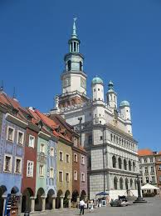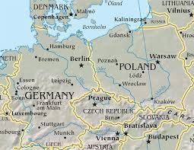
Old market

P O Z N A Ń

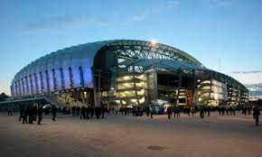

Poznań - city

